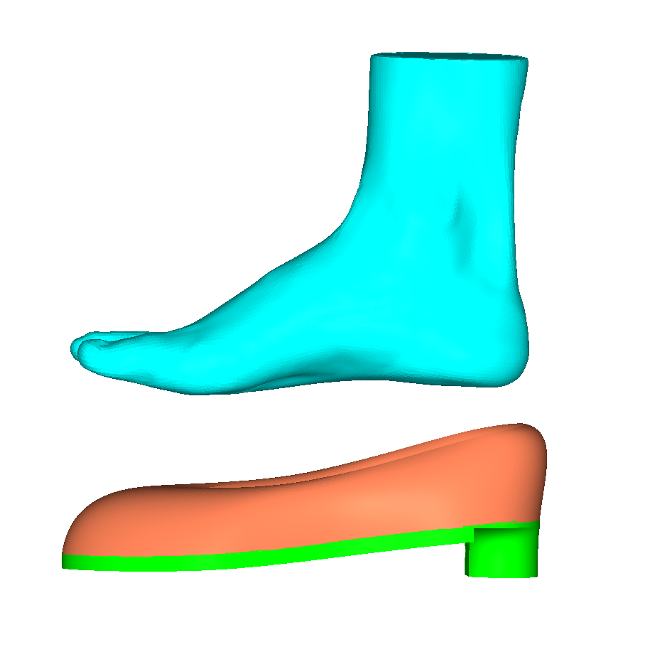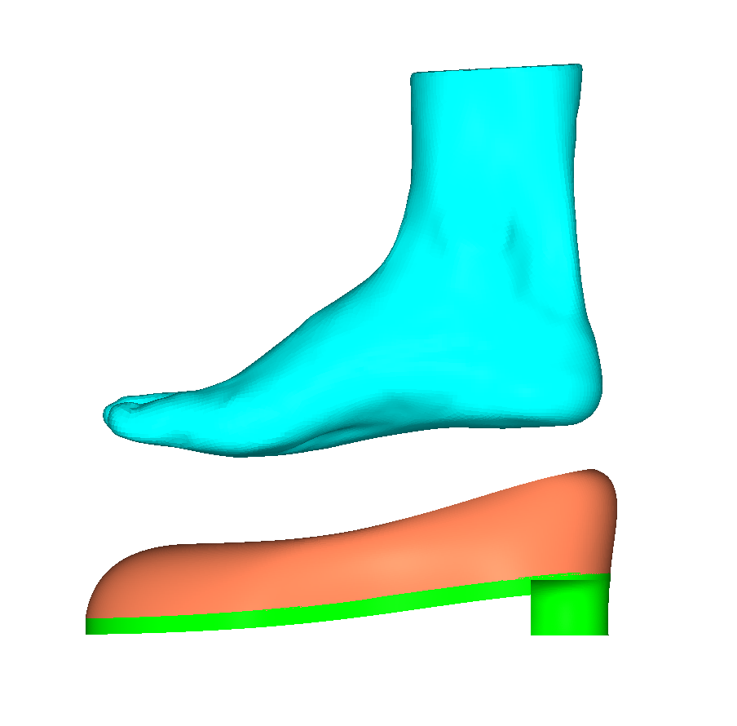
B
A
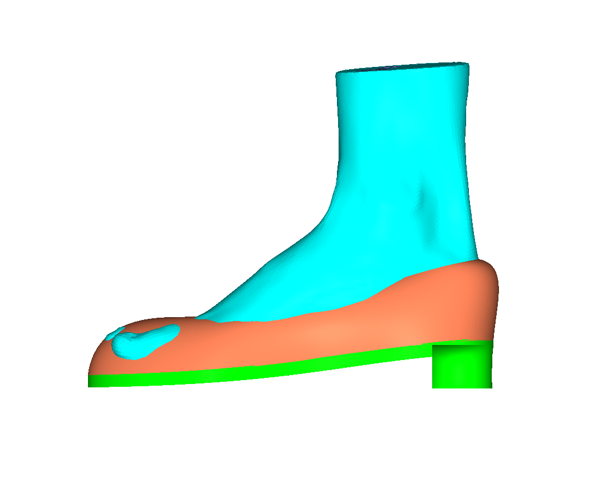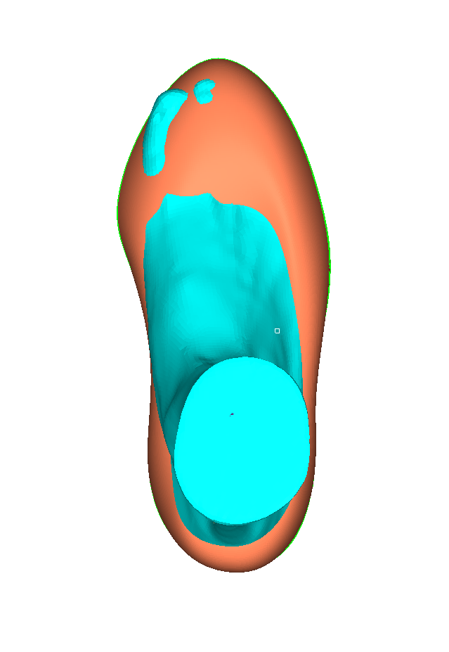
D
C
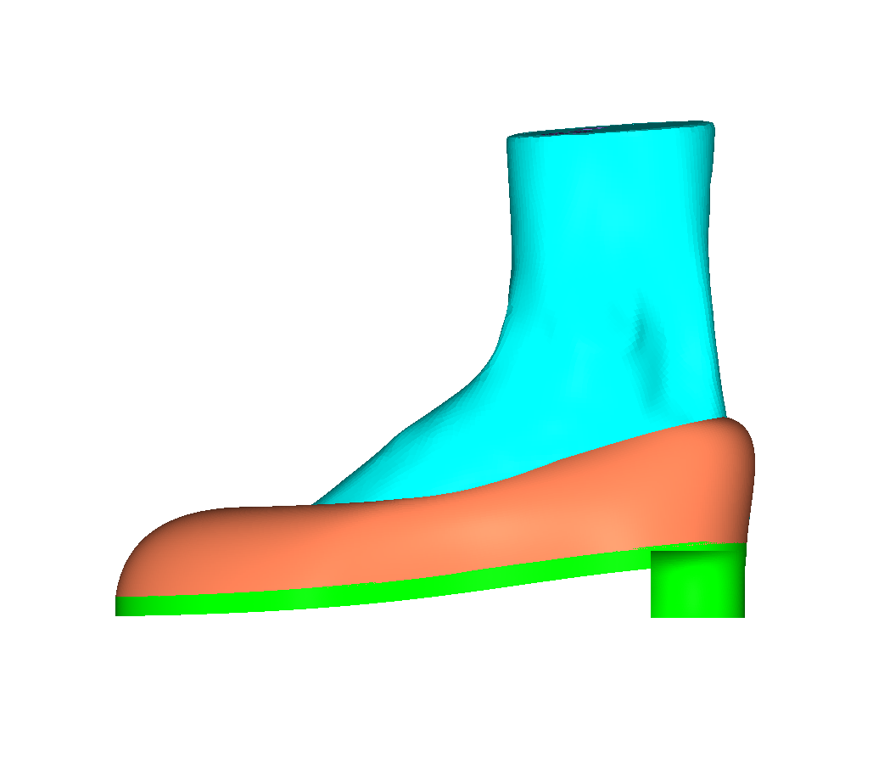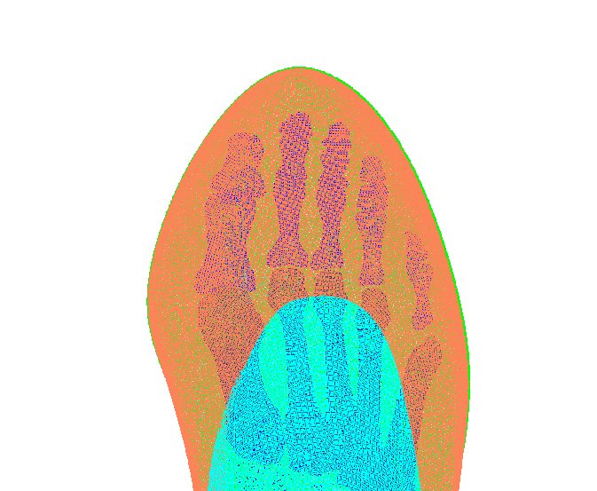
F
E
Figure. Procedures of HHS donning simulation: (A) initial position; (B) muscles forces applied to manipulate foot position; (C) contact establishment between foot and shoe sole; (D) transverse plane view of contact establishment between foot and shoe sole (E)contact establishment between foot and shoe upper; (F) release of muscles forces and displacement constraints of HHS.

